1. 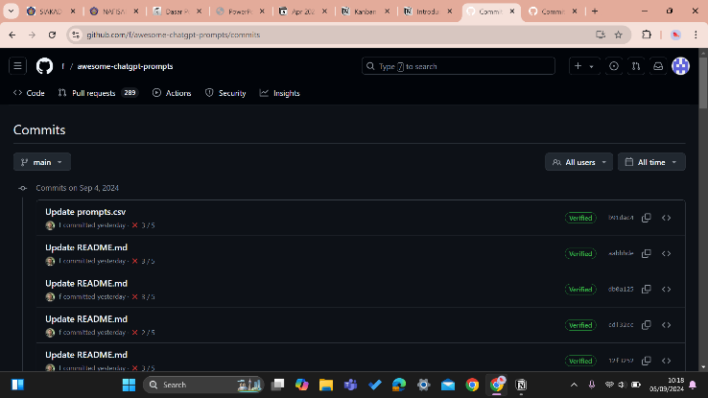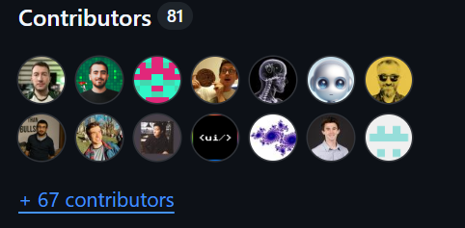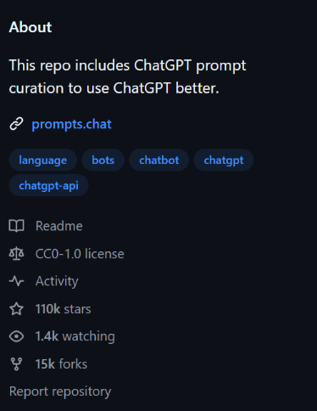
2. 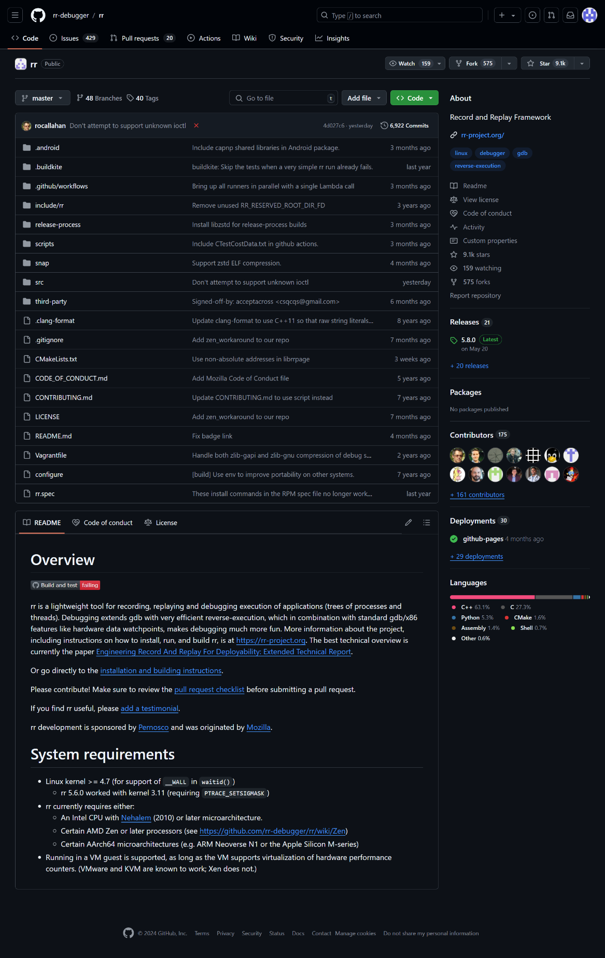

<https://github.com/rr-debugger/rr>

1. 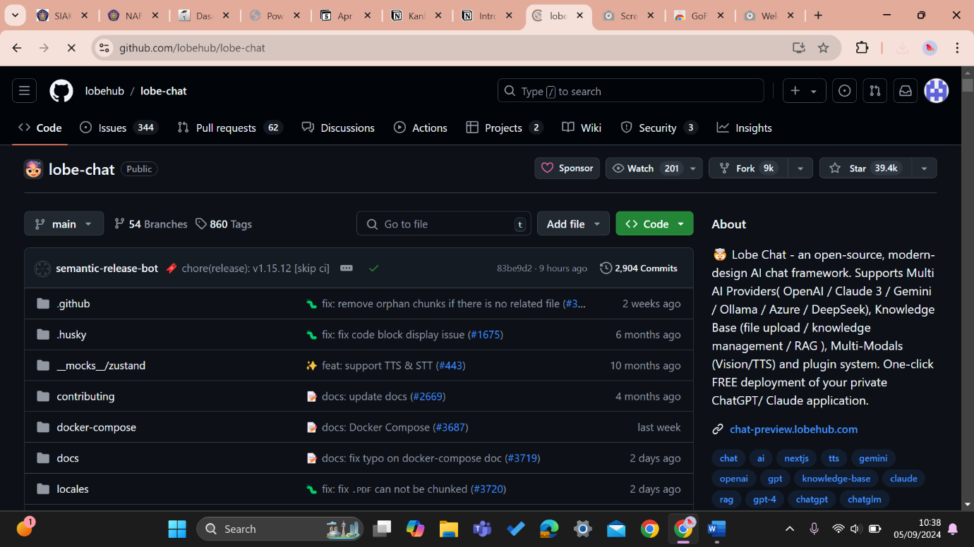

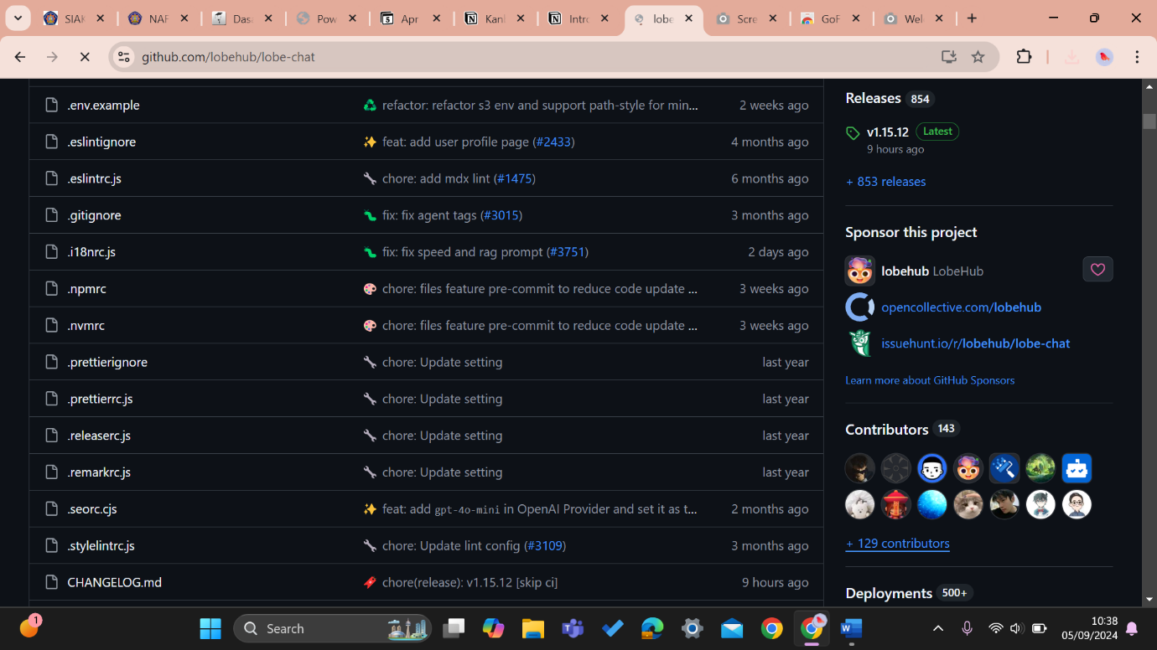

<https://github.com/lobehub/lobe-chat>

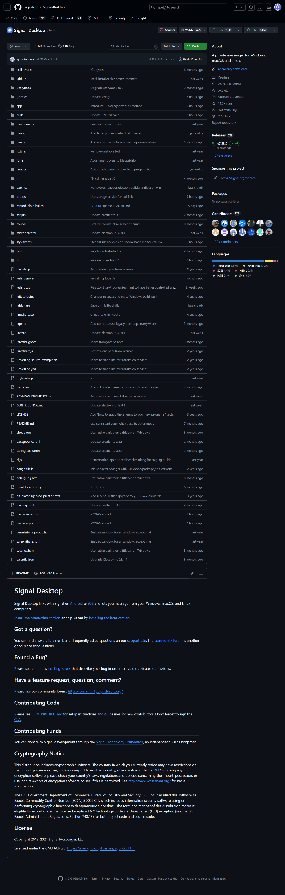

<https://github.com/signalapp/Signal-Desktop>

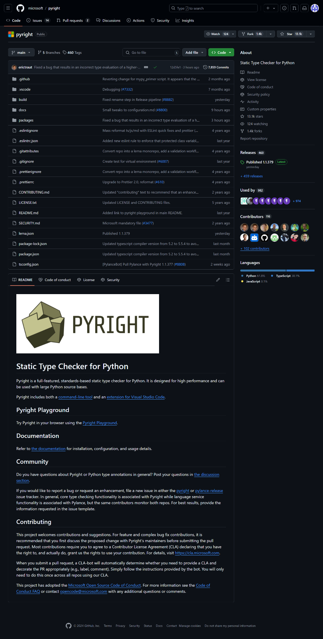

<https://github.com/microsoft/pyright>

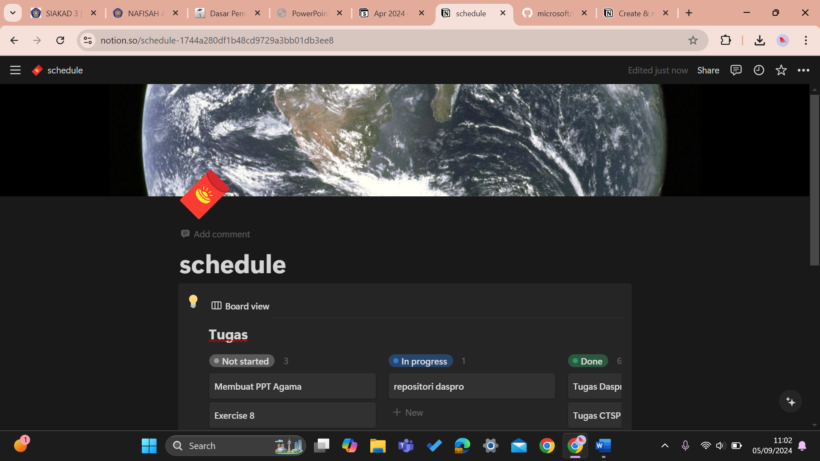

<https://destiny-tibia-61b.notion.site/schedule-1744a280df1b48cd9729a3bb01db3ee8?pvs=25>